Enhancing Cognitive Learning of Human Anatomy through Augmented Reality and Mobile Technology
Proposer: Dr. Kyle Rarey, rarey@ufl.edu, Department of Anatomy & Cell Biology, University of Florida College of Medicine, 1600 SW Archer Road, Room D2-32B, Dental Building, PO Box 100235, Gainesville, FL 32610, 352-273-5753
Sara Weitzel, sara@ufl.edu, UF Health Educational Technologies, University of Florida, 1600 SW Archer Road, Room CG-60, Communicore Building, PO Box 100152, Gainesville, FL 32610; 352-273-8498
Daniel Downey, ddowney@ufl.edu, UF Health Educational Technologies, University of Florida, 1600 SW Archer Road, Room C3-012, Communicore Building, PO Box 100152, Gainesville, FL 32610; 352-273-5509
Sponsoring Organizations: College of Medicine and UF Health IT
Purpose:
In the College of Medicine, students are required to participate in anatomy classes involving dissecting cadavers in groups and correctly navigating and identifying structures of the various systems of the human body. While students will inevitably select differing specialties, all medical students are required to complete this course. The learned anatomy will be the cornerstone of their medical knowledge in their future specialties education. This proposal aims to integrate three emerging technologies and examine their effectiveness within the medical education system in order to further enhance the existing anatomy curriculum. This proposal adheres to the University goal of enabling students to lead and influence new generations for economic, cultural, and social benefit, implementation of technologies such as augmented reality (Microsoft HoloLens – see appendix A), interactive testing (tablets), and mobile educational units (portable computer carts) allow for a more interactive and collaborative classroom.
Within this proposal, we aim to improve the learning and assessment in the anatomy laboratory with augmented reality to assist students with special awareness when interacting with the human body. Students will be able to view an approximate representation of the human body to scale and interact with it in real time to discuss issues and collaborate on locating systems. Hands-on education through dissection is invaluable and essential, but the interactions and permutations of the educational method of learning are limited due to the finite number of cadavers available. Augmented reality allows for real time collaboration between multiple students to explore and learn the human body without any limit through a variety of learning modalities. This proposal suggests using Microsoft HoloLens devices for presenting augmented reality into the Anatomy Lab. Microsoft HoloLens allows individuals to extend the reality around them, brings holograms into their real world, connect/collaborate with the people around them, and be free to walk around to interact with 3D images. The HoloLens can enable students to interact with anatomy content and information in the most natural ways possible. Built-in sensors let you use your gaze to select holograms, simple gestures can manipulate holograms and voice commands can help you complete tasks. The HoloLens can enhance teaching through individual learning or through group collaboration. (See Appendix B for images on the device and how Microsoft HoloLens works).
Interactive testing aims to improve the assessment portion of anatomy classes and has potential to expand to other courses. One of the most imperative and defining steps for mental conditions of learning for education today, according to Robert Gagne’s Nine Events of Instruction, is assessing performance. This step is commonly manifested as a quiz or test, but within an anatomy lab, there can be uncontrollable factors such as space, number, and integrity of the cadavers. A new initiative utilizing dedicated mobile devices, such as tablets, would allow educators to include more beneficial, interactive examples for each question. Overall, this would provide educators with the tools to create better assessments of anatomical knowledge imperative to the students’ educational foundation.
Finally, mobile educational units (portable computer carts) can allow students to review the dissections of other student teams in a more efficient manner while also providing mobile references during dissections. These carts would be easy to move within the classroom and have the capability to stream a camera view directly from the carts to other monitors throughout the anatomy lab. Within the anatomy labs, space is an issue and it can be difficult for more than a few students to adequately view unique or important structures the educators may want to point out. With this technology, educators could quickly stream their demonstration allowing the entire class to participate while spread out through the classroom and this could take place at any of the anatomy tables.
Impact/Benefit:
The incorporation of these three technologies can directly and inevitably impact the 280 first and second year medical students and the faculty who support the medical anatomy classes. Currently, the proposed initiative is focused on this group of medical students, but these technologies can transitioned to teach students in Dental, Physician Assistants, Physical Therapy programs and 4th Year anatomy elective medical students. The aim of the initiative is to enhance the existing anatomy materials to provide greater educational benefits for students and enable faculty to provide higher quality education with minimal additional effort. The current structure of utilizing cadavers in the dissections would continue to exist, but these technologies would blend with existing content such as scans of each cadaver for the year to implement the cadavers in new ways. As time progresses, specific cadavers with unique characteristics could have their digital information saved to use in future courses. These technologies encourage utilization and storage of past information in order to create a robust library of educational resources.
Benefits to Student Learning:
This proposal references three different technologies, which can impact the learning in the classroom. Each of the technologies can directly affect how students engage with educational materials and each provides a unique form of feedback. Students can be more hands on with dissections and work together to locate and discuss issues utilizing Microsoft’s augmented reality through HoloLens. Educators can present rare or unavailable scenarios for students to interact with within 3D space and gain all of the advantages of dissection except for the tactile feedback.
Interactive testing with tablets directly affects the quality of examination, while also improving examination conditions. Often exams can be tedious as the pre-prepared cadavers offer limited space for students to cycle through and accidental interactions can cause other students to answer questions incorrectly due to pivotal indicators being moved. With interactive testing, examinations can be more efficient as more students can move through the space at one time and each question could be reset after students complete it. This allows students to freely interact with simulated questions and move them as needed without impairing other students’ tests.
Mobile educational computer carts allow for additional feedback and learning guidance within classes without slowing down the class as a whole. Instead of gathering around a group’s cadaver and slowing down all dissection, the educator can demonstrate the point and quickly stream it throughout the laboratory. In addition, the mobile units have the potential to display interactive views of the cadaver bodies currently being dissected, similar to the currently used technology of the Sectra Table or Virtual Human Dissection (VHD). Students would be able to load images of their assigned cadaver and interact with it on the mobile cart before proceeding with the actual dissection.
Benefits to Faculty Productivity & Effectiveness:
Each of the technologies increases the educational effectiveness within the classroom as well as enables educators to focus more on in-depth questions rather than spending time answering simple questions. The HoloLens allows students to examine and interact with their cadaver before and after the dissection happens through scans. Interactive testing allows for more targeted testing materials and allows faculty to pull questions from previous semesters without issue. As time progresses, faculty become more efficient at creating high quality quizzes and tests based on the bank of questions available to them. Inside the anatomy labs, it can be challenging to have students gather around a single cadaver to point out specific structures or issues. Students need to cycle close to the front requiring educators to remain at the cadaver for a significant time for all students to receive the same quality of instruction. The mobile educational unit will allow all students to quickly observe any necessary structures without additional time or effort from the faculty member. Additionally, the unit will allow students to view their assigned cadaver scans as they dissect, eliminating some simpler questions and allowing the educators to focus on guidance and more in-depth instruction during dissection.
Benefits to HSC:
These educational technologies aim to improve the quality of learning and assessment in anatomy laboratories and to enhance any existing products. It does not aim to remove the need for dissection as this is a vital part of the educational process. These technologies will blend with the traditional approach to learning medical anatomy. The bodies being dissected are scanned each year and students can interact with scanned images through an existing technology called the Sectra Table. While this technology is used extensively, the size of the table and limited availability can be problematic for students as it is not easily mobile. These technologies would allow them to interact with the same scans, in the gross lab, that are already being utilized to provide more collaborative and interactive education.
Effective Assessment:
In order to determine the effectiveness of the technologies, faculty will analyze their use and issues encountered while utilized during the course. Faculty will record any issues that arise while developing and utilizing the content to best determine the ease of use. Assessment scores will be compared from past classes that functioned without these technologies to see if any academic improvement can be seen in quizzes and tests. Additionally, students will be surveyed throughout each semester to determine their thoughts on each of the technologies. Educational improvements need to be supported by the students or modified to ensure that students feel their education is positively impacted by the utilization of these technologies.
Sustainability:
Initially, the project will consist of experimenting with each of the associated devices within the three technologies, but should the project become completely integrated, educators should consider how additional devices will be obtained if necessary. The scans of the cadavers already exist for use within the Sectra table and should not require any additional funding to implement them across additional devices or servers. Once the program is developed this technology could easily be utilized in our adjacent gross laboratories.
Americans with Disabilities Act (ADA):
ADA compliance is a high priority in this initiative and the technologies discussed directly assist with various accessibility issues within the classroom. Educators have noticed that students occasionally have trouble with spatial awareness when viewing anatomy of the human body. All three of these educational technologies have the capability of manipulating the models within 3D space to identify anatomical structures in relation to other structures. HoloLens can assist to prepare students to be more efficient during dissection or help them review structures long since dissected before an assessment. Interactive testing units will provide model manipulation for applicable questions allowing students to examine structures that are being tested on in real time and improving their chance of selecting the correct answer. Students will be able to utilize the mobile educational carts to examine anatomy models on an interactive screen similar to the HoloLens; therefore assisting teams with their dissection without the need to pull out textbooks or phones, which will not have the same degree of interaction as the mobile units.
In addition, visual impairments are another ADA concern to be considered. While visual impairments may prevent students from entering certain specialties, they will still need to complete the anatomy course to continue in their education. All three of these technologies have the potential to assist with highlighting systems that may be difficult to identify during dissections. This also benefits others without visual impairments, as it may be difficult to initially identify structures within a cadaver. Highlighting structures and manipulating them will allow self-directed learning and assessment in the hands of the students.
Security:
The anatomy lab is a secure area with key-code door access. The requested technology will be solely located in this lab for students to use during and after class hours. The Microsoft HoloLens will undergo a security evaluation and the settings/security configurations on the devices will be tailored to the HSC Center standards. BitLocker data encryption and secure boot is enabled on HoloLens to provide the same level of security protection as any other Windows device. The Von Hagens digital resource will comply with the publisher’s permission to release the digital copy. The tablets (along with tablet cases and floor stands) will be stored in CG-83A, which is located behind CG-83 and accessible through a door only in the lab. The tablets will comply with the existing standards of mobile devices for the Health Science Center. The computer on wheels cart will be ordered through UF Health Asset Management to comply with organization standards. Lastly, security cameras will be installed into the lab to ensure portable devices (tablets, HoloLens,etc.) will not leave the lab without authorized permission. Once the equipment is in place, a series of demonstrations will be conducted in an adjacent space (without cadavers) for students and faculty from other programs to experiment and try out the technology.
Future Expansion:
After Spring 2020, feedback and assessments should be complete. The curriculum and materials will be adjusted to align with the course and fully be embedded in the curriculum. The future goal would be to partner and leverage the 3-D technology in adjacent labs (PA, Dental, Neuroscience, etc.) and on main campus to enhance collaborative learning. Only a handful of universities are currently exploring similar technologies. This project could provide an opportunity to collaborate with other universities as well as our internal information technology teams to potentially expand and build customized apps that would work with the existing technology.
Reference/Resources:
Best, Jo. “HoloLens, MD: Why This Medical School Will Teach Doctors Anatomy with Microsoft's Augmented Reality, Not Cadavers.” ZDNet, ZDNet, 15 Dec. 2016, www.zdnet.com/article/hololens-md-why-this-medical-school-will-teach-doctors-anatomy-with-microsofts-augmented-reality-not/.
CWRU HoloLens Case Studies. Case Western Reserve University, case.edu/hololens/.
“Facts About Color Blindness.” National Eye Institute, U.S. Department of Health and Human Services, 1 Feb. 2015, nei.nih.gov/health/color_blindness/facts_about.
“Microsoft HoloLens: Partner Spotlight with Case Western Reserve University.” Microsoft HoloLens, https://www.youtube.com/watch?v=SKpKlh1-en0.
Murthi, Sarah, and Varshney, Amitabh. “How Augmented Reality will make Surgery Safer.” Harvard Business Review, 20 Mar. 2018, https://hbr.org/2018/03/how-augmented-reality-will-make-surgery-safer.
Nicholson, Daren T., Chalk, Colin, Funnell, W Robert J, Daniel, Sam J. “Can virtual reality improve anatomy education? A randomized controlled study of computer generated three-dimensional anatomical ear model.” Medical Education, Wiley Online Library, 17 Oct. 2006, Vol. 40, Issue 11; Pgs 1081-1087.
“UCSF Anatomy Learning Center.” Anatomy Learning Center - UCSF Medical Education, meded.ucsf.edu/anatomylearningcenter.
“Weill Cornell's IPad Revolution Reaches Gross Anatomy Lab.” WCM Newsroom, Weill Cornell Medicine, 23 Aug. 2013, news.weill.cornell.edu/news/2013/08/weill-cornells-ipad-revolution-reaches-gross-anatomy-lab.
Project Timeline:
- April 27, 2018 – Acceptance Notification
- May 2018 – Start Security Evaluation for Microsoft HoloLens devices
- June - August 2018 – Consult with HSC Security/PPD on developing plan to install security devices; retrieve official quotes for equipment purchase
- August/September 2018 - Funds Distributed
- September/October 2018 – Equipment Ordered
- November 2018 – Equipment delivered and installed
- December 2018 – Spring materials developed and student demos
- January 2019 – July 2019 – Roll-out tablet soft utilization with focus groups of medical students in ICM 2
- August 2019 – Assess tablet interactive testing
- Fall Semester 2019 – Roll out HoloLens, Computer on Wheels to Curriculum
- December 2019 – Assess augmented reality and mobile educational unit
- Spring Semester 2020 – Review program and modify curriculum accordingly

Budget Table:
Item | Quantity | One Time | Annual Maintenance
Microsoft HoloLens Device (one device per cadaver) | 18 ($4600 ea) | $82,800 | Not yet established for this device
HoloLens Development Device | 1 ($3000ea) | $3000 | Not yet established for this device
Development Consulting | 20 hours ($125/hr) | $2500 | 0
Von Hagens Digital Book (anatomy educational resource for tablets) | 150 copies (sold from publisher in 50 quantities) this will allow one full medicine class to have books at one time. | $4500 | 0
Security Cameras (2 infrared illuminator capable cameras includes installation and LAN connects) | 1 system with two cameras; space to store video feed for 30 days | $10,000 | ** No annual maintenance if you expand cameras in future; additional server will need to be required.
tablets | 25 ($425 ea) | $10,625 | 0
tablet cases | 25 ($60 ea) | $1,500 | 0
tablet charging station | 1 (holds 20 tablets) | $2,000 | 0
tablet Rolling Floor Stands | 20 ($125 ea) | $2,500 | 0
Portable Computer on Wheels (computer, cart, camera) | 1 ($6500 ea) | $6,500 | 0
Proposal Request Total |  | $125,925 | 0

Appendix A – Images/Floorplan of Anatomy Lab
Floorplan Layout of Communicore Gross Anatomy Lab (CG-83, 84, 86,87)
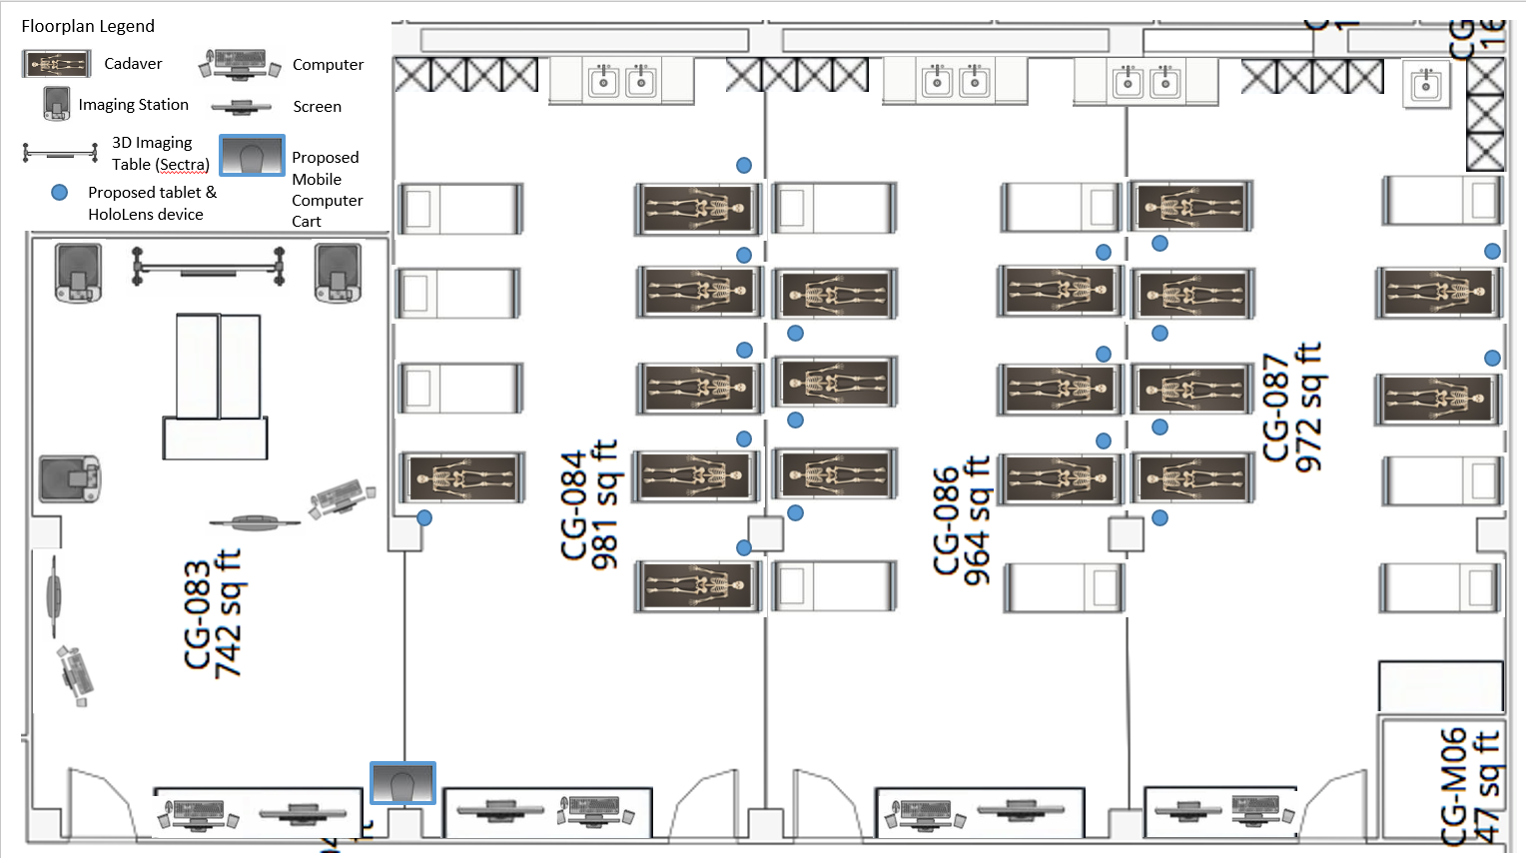

Picture of CG-83 from Door
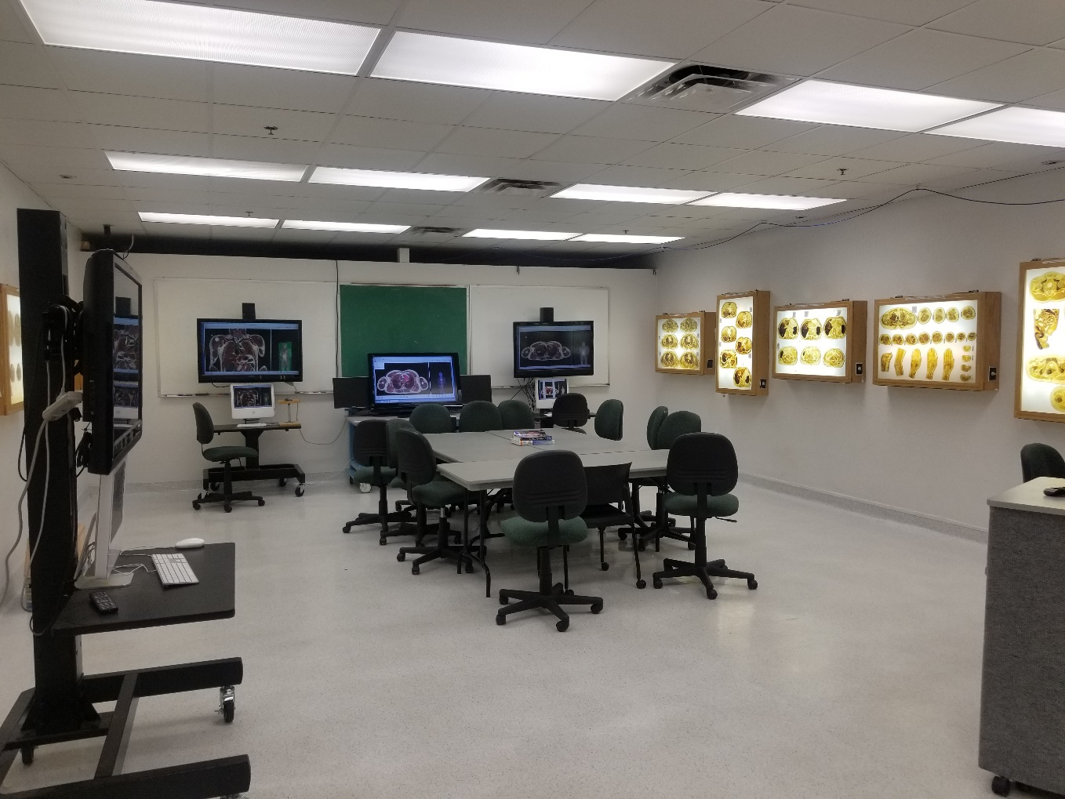
Picture back of CG-86 by sinks looking towards main entrance
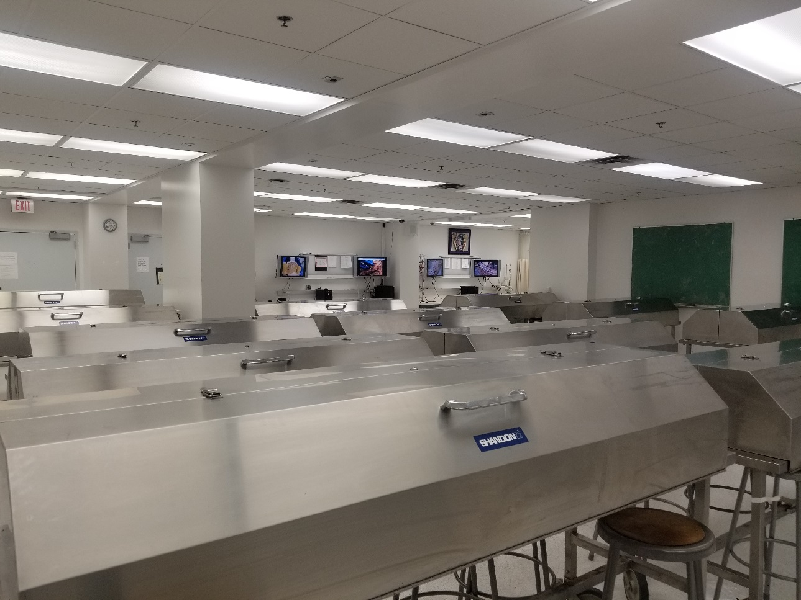
Appendix B – Images of HoloLens Device
Photo Credits: Microsoft¹, Case Western University²
Microsoft HoloLens allows you to extend the reality around you, brings holograms into your real world, connect/collaborate with the people around you, and be free to walk around to interact with 3D images. Device images pictured below.¹

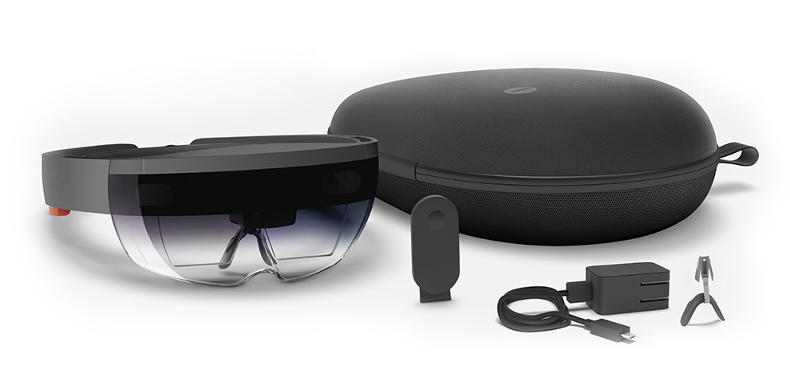
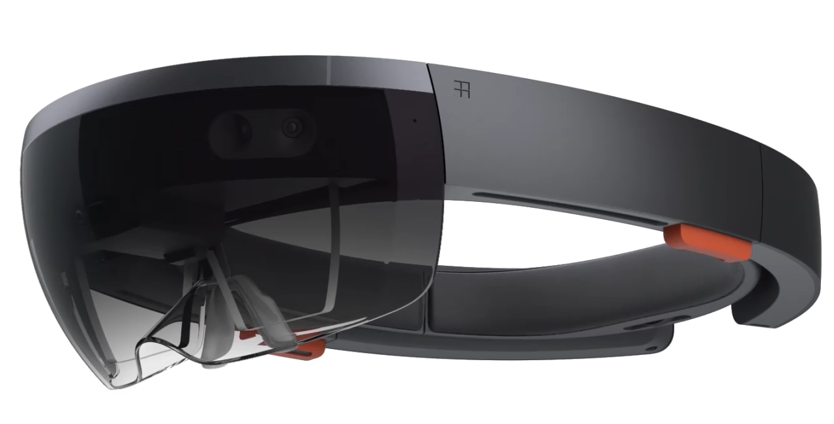

HoloLens enables you to interact with content and information in the most natural ways possible. Built-in sensors let you use your gaze to select holograms, simple gestures can manipulate holograms and voice commands can help you complete tasks. Interactions pictured below.¹

Enhanced Interactivity of 3D Holograms for Individual Learning²
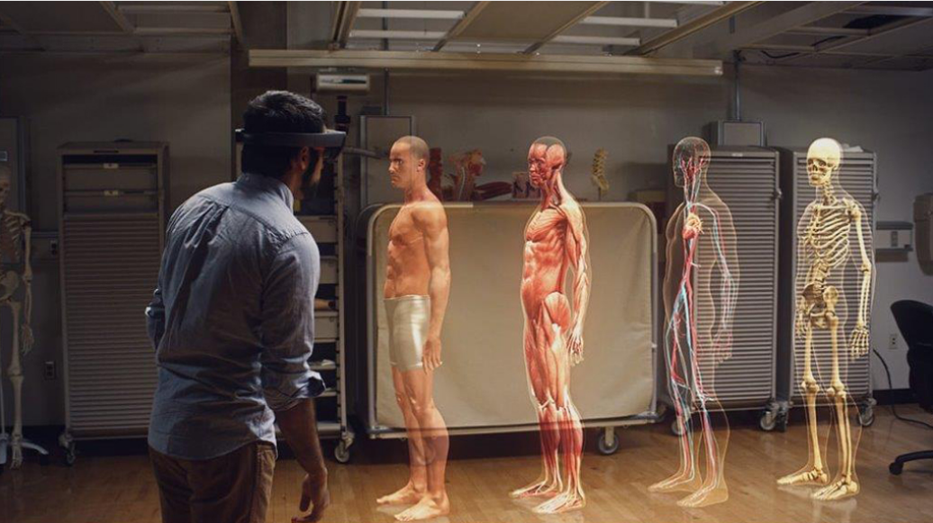

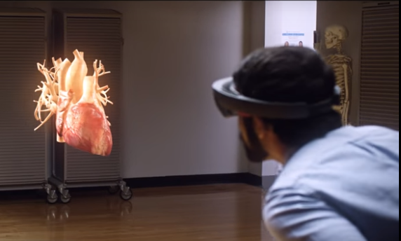
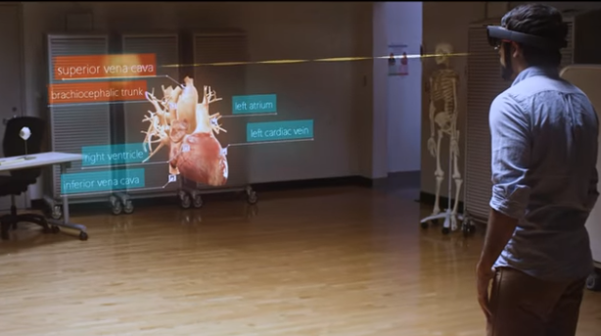

Enhanced teaching through collaboration and group work²
