UFIT Project Scope and Strategy
PPM# |  |  | Project Name
Author |  |  | Date

UFIT Request Lifecycle

Sponsors
Executive Sponsor(s) | Functional Sponsor(s) | Technical Sponsor(s)

Scope Definition & Management Plan
This document identifies the project scope by defining scope boundaries and elaborating on what should be included and excluded from the project. It identifies the process for scope change and control.

Scope
Clearly define the project scope by elaborating what should be included and excluded from the project.

In Scope
Examples include:
- Implementation of new product/service
- Data conversion(s)
- Proof of Concept to meet compliance boundary(s)
- Proof of Concept of integration(s)
- Integration and use of existing environments within UFIT
- Training of Staff
- Data integrated into UF data warehouse

Out of Scope
Examples include:
- Change to enterprise systems
- Changes to policy and procedure
- Data conversion of historical (non-current) customer data
- Integrations outside of project space

Scope Verification and Project Acceptance
Example:
Existing scope will be vetted through regular project team meetings and validated by the Project Sponsors and or Program Managers for completeness. Meeting minutes or email confirmation will be acceptable media options.

Scope Control

Scope Monitoring and Management
Example:
The project team will ensure the requirements meet the scope by using a traceability matrix or alternative document. This matrix will be reviewed by the customer stakeholders for acceptance that their needs are being met by the requirements. This information will be documented as part of the project and reviewed by the Program/Project Managers on a weekly basis.

Determine how scope is measured and verified
Example:
The Functional Requirements Document (FRD), Stakeholder Requirements, Business Requirements, and the Traceability Matrix will provide the necessary baselines which will allow the project team to validate that scope is measured and verified.

Scope change process
Example:
The Project and Program Management resources will control scope of the project by using the existing project structure to collect, review, and accept any changes after the original scope has been agreed to by the stakeholders and sponsors. The Project Manager will record the scope change by creating a Project Change Request in PPM and route it to the appropriate Project Sponsor for approval.

Deliverables
Populate the provided table the project deliverables. Examples include:
Name | Description & Acceptance Criteria | Approver(s)
Functional Requirements Document (FRD) | Management agrees that the requirements meet the business needs  - Functional Requirement Document [LINK]  - Supplemental Requirements Document [LINK]
Architecture Documentation | Documentation of the technical architecture that supports the new service  - Architecture Diagram [LINK]
Instance Management Strategy | Each instance that is created meets the compliance boundaries of securing data  - Instance Management Plan [LINK]
New Infrastructure Installed and Ready for Use | Infrastructure for new application has been installed and tested
New Application or Service Ready to Use | The application or service is live, and customers are able to use it.
Documentation & Training Materials | Documentation and training materials for the new application/service
Dashboards and Reports | Visualizations including dashboards and reports used to support the application or service.

Timeline
Insert screenshot of Microsoft Office Timeline or other visual timeline graphic. Example:
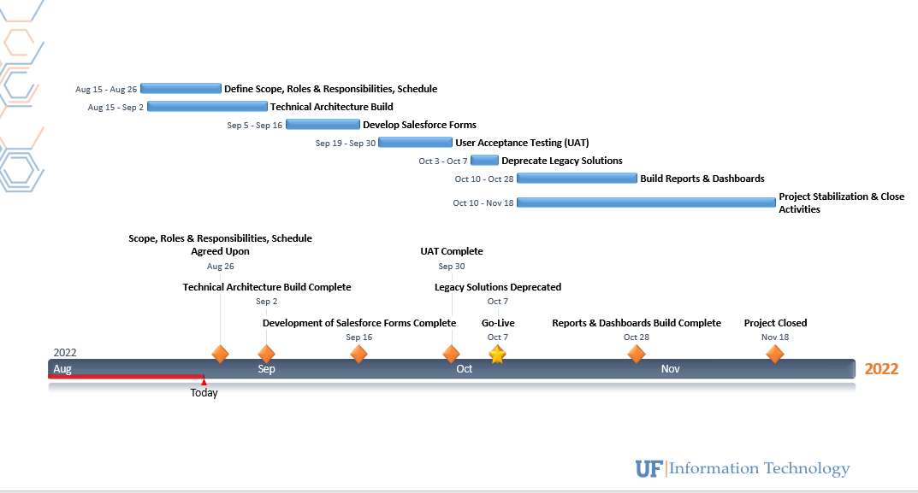

Milestones
Populate the provided table with the project milestones. Examples include:
Milestone Description | Planned Finish Date
New Infrastructure Installed and Ready for Use | [MM/DD/YYYY]
Test Environment Operational

Production Environment Operational

Onboarding, Documentation, Processes Complete

Project Complete

Known Considerations
List any assumptions, constraints, and risks in the sections below.

Assumptions
- Project deployment will be dependent on the substantial completion of project(s):
  - Impact if false:
- Resource limitations between the following projects will drive the timelines as listed:
  - Impact if false:

Constraints
- Will have adequate access to system(s) and/or data (within ecosystems)
  - Impact if false:
- The project is not dependent on another project timeline
  - Impact if false:

rISKS
- Departure of key project team member(s)
- Project Pace
- System configuration and/or functionality

Strategies
Elaborate on any of the following applicable strategies and/or approaches for your project. As needed, address instance management and integrations across the different systems when defining approaches.

Project Strategy/Approach

Architectural Approach
Project role responsible (Technical Lead and Architect) for explanation and examples
[DESCRIBE APPROACH HERE]

Design Approach
Project role responsible (Technical Lead/Functional Lead) for explanation and examples
[DESCRIBE APPROACH HERE]

Development Approach
Project role responsible (Technical Lead) for explanation and examples
[DESCRIBE APPROACH HERE]

Funding Approach
Project role responsible (Executive/Functional Sponsor) for explanation and examples
[DESCRIBE APPROACH HERE - determine if it is existing funding, new funding, or auxiliary funding]

Quality Assurance Approach
Project role responsible (Testing Lead or Testing Analyst) for explanation and examples
[DESCRIBE APPROACH HERE]

Communication Approach
Project role responsible (Communications Lead/Project Manager) for explanation and examples
[DESCRIBE APPROACH HERE]

Training Approach
Project role responsible (Training Lead/Business Analyst) for explanation and examples
[DESCRIBE APPROACH HERE]

Deployment Approach
Project role responsible (Technical Lead/Functional Lead/Project Manager) for explanation and examples
[DESCRIBE APPROACH HERE]

Requirements
Link to requirements document (to include business requirements, functional requirements, non-functional requirements, and transitional requirements), prepared by analyst on the project.

Testing
Indicate the general testing strategy for this project by selecting the types of tests to be executed for this project:
☐ Pre-Modification Testing (Baseline)  ☐ Unit Testing (Developer)  ☐ Functional Test  ☐ Integration Testing  ☐ Process (End-to-End) Testing | ☐ User Acceptance Testing  ☐ Load Testing  ☐ Parallel Testing  ☐ Regression Testing  ☐ Post-Production Testing
Testing Strategy Example: [LINK]

Institutional Costs
This section refers to any costs against the University of Florida, including resource and financial costs.

UFIT Financial Costs
Link to cost analysis documentation (includes quotes, purchase orders, licensing costs, etc.).
Link to high-level cost information in a snapshot view/chart.

Campus Financial Costs
Cost Description | Amount ($) | Frequency (e.g., Once, Annually)
 | $

Project Scope and strategy Approval
Name | Role | Date

